Physics 319 Laboratory: Optics
Diffraction II
(Spring 2025 version)
Objective: To continue the exploration of diffraction effects which you started last week.
Apparatus: You will need the same setup as last week.
Theory: (Hecht, sections 10.1 to 10.2.2 & 10.3.5) According to Fresnel’s theory of diffraction, an opaque object should have a diffraction pattern with a central maximum, as shown in Section 10.3.4 in Hecht (figure is unlabeled in 4th edition). That this prediction runs counter to common sense – an opaque object casting a shadow with a bright spot in the center – was used as an argument by Simeon D. Poisson in 1818 to refute Fresnel’s theory. Fresnel’s prediction was almost immediately verified by experiment, winning him an award and a title from the French Academy. The bright central maximum has ironically been named Poisson’s Spot.
Fresnel’s theory of diffraction is based on the summation of electric field amplitude vectors arriving at the diffraction pattern from different parts of the diffracting object. Some of these electric field vectors will end to increase the overall electric field, and hence the irradiance, at points of the diffraction pattern, and other electric field vectors will tend to decrease the overall irradiance. Fresnel reasoned that if one were to block the areas where the electric field vectors tend to subtract from the overall irradiance at the center of the diffraction pattern (see Figure 10.46 a and b in Hecht), then the resulting Fresnel Zone Plate would have the effect of intensifying the light at a point. This is another surprising result of Fresnel’s theory: that blocking some of the light has the effect of focusing the remaining light to a point.
(Hecht, section 10.2.2) Last week you observed single slit (Fraunhofer) diffraction. Another simple diffraction pattern is the double slit diffraction pattern. The irradiance of the double slit is given by
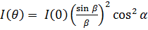,
Where α = (ka/2) sin(θ), β = (kb/2) sin(θ), b is the slit width, and k is the wavenumber of the illuminating light, and a is the “center to center” slit separation. Notice that this expression is simply a cos² term modulated by a single slit diffraction pattern. See Figure 10.18 in Hecht.
Procedure:
- Alignment
Check the alignment of the optics bench following the directions in the previous lab procedure

- Poisson’s Spot
Illuminate a small opaque dot (slide OS-9126) with the laser. Observe the diffraction pattern on the wall. If the pattern is not clear, use a lens and viewing screen arrangement (with the screen at the focal plane of the lens). Observe Poisson’s spot. Sketch the pattern and discuss.

- Fresnel Zone Plate
Assemble a beam expander (see last week’s procedure) and place a Fresnel zone plate (slide OS-9126) in the expanded beam. The zone plates have been designed to have a focal length of 40 cm. Place the viewing screen in the focal plane and observe the central dot.

Assemble the linear translator and photometer setup, with the fiber optic cable 40 cm from the Fresnel zone plate. Scan the pattern with the translator and compare the irradiance of the central dot with the irradiance of the unobstructed beam. In order to compare irradiances, cover the fiber optic probe with a light source aperture (slide OS – 9118 and – 9119) which is at least as small (if possible) as the central dot in the Fresnel pattern. Use the same aperture when scanning the unobstructed beam. Discuss your findings.

- Double Slit Diffraction
Set up the optics bench to observe the Fraunhofer diffraction pattern of a single slit as done in the last lab. Find a double slit (on slide OS-9165B) with the same slit size as the single slit. Switch back and forth between the two, observing the differences in the diffraction patterns. Record these differences.

As you did with the single slit last week, record and plot the diffraction pattern for double slit diffraction. You will need to take a lot of data to resolve the interesting features of the pattern. Take your time. Plot data to verify the equation given in the theory section.

Questions:
1. Compare and contrast the diffraction patterns between a single slit and double slit of the same size. See figure below.

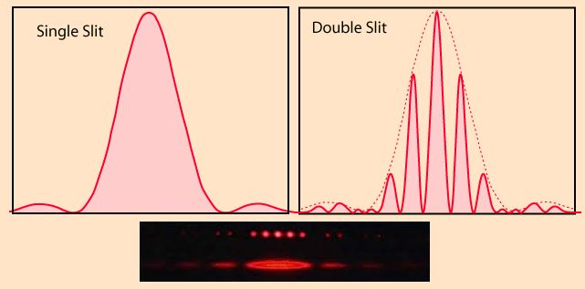
Figure 29-3 Single & double slit diffraction patterns
Image is from website
https://physics.stackexchange.com/questions/239431/youngs-double-slit-number-of-fringes
2.Using your observations and your graphs, explain what is meant by “Notice that this expression is simply a cos² term modulated by a single slit diffraction pattern” from the theory section.

To help visualize what this statement means, I have included an example of wave modulation.

Please note that the ‘carrier wave’ in our case is the cosine squared pattern (i.e., the intensity of a double slit is given by a cosine squared term*). and its amplitude is ‘modulated by a single slit diffraction pattern’(intensity). We are interested in the C signal (i.e., Amplitude modulated wave). See website below also:

https://phys.libretexts.org/Bookshelves/University_Physics/Book%3A_University_Physics_(OpenStax)/University_Physics_III_-_Optics_and_Modern_Physics_(OpenStax)/04%3A_Diffraction/4.04%3A_Double-Slit_Diffraction

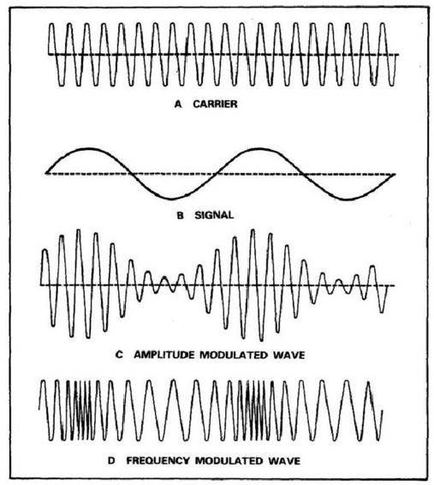

3. Make a copy of your double slit plot and do the following. (If your plot does not look like a good double slit plot use the attached plot on next page. Please note that although we discussed the evenly space maxima in a double slit diffraction pattern, the dark patterns are also evenly spaced and easier to mark so we will use them in this exercise.
a) Mark the four dark spots in the central pattern using vertical lines that cross
x-axis. Measure the distance between the outside lines and divide by 3 (since this determines 3 patterns). This will give you a pretty good average of the width a single dark pattern.
b) Mark all of the dark spots on the plot. You should have 13 or 14 lines.
Discuss whether your patterns are evenly spaced.
4. Explain the bright spot in the center of part 2 (The Poisson Spot). Can it be explained by a particle theory of light?

